Table of Contents
Chapter 1: Development Tools and Environments
1.1 Development Platform .................................................. 2
1.2 Development Tools ....................................................... 2
1.3 NuGet Packages ............................................................ 3
1.4 External API .................................................................. 3
1.5 Data Storage System ..................................................... 3
1.6 System Requirements ................................................... 3
Chapter 2: Main Interface of the Application
2.1 Boot Screen .................................................................. 4
2.2 Main Browser Window ............................................... 4
2.2.1 Custom Title Bar .................................................. 4
2.2.2 Tab Bar ................................................................. 5
2.2.3 Toolbar ………………………............................. 5
2.2.4 Content Area ......................................................... 6
2.3 Modal Windows and Popups ...................................... 7
2.3.1 AI Summary Window .......................................... 7
2.3.2 Bookmark Manager .............................................. 7
2.3.3 History Viewer .................................................... 7
2.3.4 Downloads Manager .......................................... 7
2.4 Incognito Mode Visual Differences .......................... 8
Chapter 3: Conclusion and Project Development Direction
3.1 Achievements ........................................................... 9
3.2 Limitations ................................................................ 9
3.3 Next Development Roadmap .................................... 9
Conclusion ................................................................ 11
Project Link + References ………………..…………11

CHAPTER 1: DEVELOPMENT TOOLS AND ENVIRONMENTS
1.1 Development Platform
MyWebBrowserVer4 is developed on Windows Presentation Foundation (WPF) combined with .NET 8, the latest Long-Term Support (LTS) version from Microsoft.
Reasons for choosing WPF:
- Powerful framework with highly customizable UI
- Supports XAML for declarative interface design
- Sophisticated MVVM pattern and data binding
- GPU acceleration for better graphics performance
- Rich control library and flexible styling system
- Perfect integration with Windows ecosystem
.NET 8 Features:
- LTS version with long-term support
- Significant performance improvements, 20–30% faster than .NET 6
- Enhanced garbage collection reduces memory footprint
- Improved async/await patterns for I/O operations
- Modern C# 12 language feature
1.2 Development Tools
Main IDE: Visual Studio 2022 (Community Edition)
Required workloads:
- .NET Desktop Development
- Universal Windows Platform Development
Useful extensions:
- XAML Styler: formats XAML code
- ReSharper: code quality analysis
- GitHub Copilot: AI coding assistant
SDK Requirements:
- .NET 8 SDK ≥ 8.0.100
- Microsoft Edge WebView2 Runtime
- Windows 10 SDK ≥ 10.0.19041.0
1.3 NuGet Packages
Package | Purpose | Features
Microsoft.Web.WebView2 | Embedded browser | Chromium-based, HTML5/CSS3/JS support, regular security updates, native Windows integration
Dragablz | Advanced tab management | Drag & drop tabs, tear-off tabs, docking, custom styling
DotNetProjects.WpfToolkit.Input | AutoCompleteBox | Smart URL suggestions, async data population, filtering, keyboard navigation
Newtonsoft.Json | JSON handling | Save/load history, bookmarks, download metadata
HtmlAgilityPack | HTML parsing | Extract metadata, DOM manipulation, XPath queries

Installation: Install-Package <PackageName>
1.4 External API
Google Gemini AI API
- Endpoint: https://generativelanguage.googleapis.com/v1beta/models/gemini-1.5-flash:generateContent
- Authentication: API Key
- Model: gemini-1.5-flash
- Functionality: Content summarization, text generation
‘

CHAPTER 2: MAIN INTERFACE OF THE APPLICATION
2.1 Boot Screen (Mode Selection)
Khi khởi động ứng dụng, người dùng được chào đón bởi InfoPanel - màn hình lựa chọn chế độ duyệt web với thiết kế clean và hiện đại.
Cấu trúc giao diện:
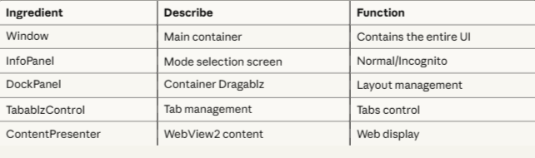
Screenshot mô phỏng:
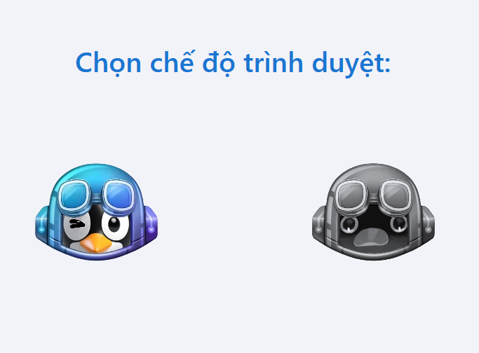
2.2 Main Browser Window
After selecting the mode, the main window opens with a fully functional layout.
2.2.1 Custom Title Bar
Vị trí: Top of window
Components:
- Left: Application icon (16x16) + Window title
- Right: Window controls
  - Minimize button (−)
  - Maximize/Restore button (□/⧉)
  - Close button (✕) - red on hover (#E81123)
Screenshot mô phỏng:
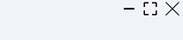
2.2.2 Tab Bar (Dragablz Control)
Vị trí: Dưới title bar
Tab Appearance:
- Shape: Trapezoidal (modern look)
- Active Tab: White background, blue accent border-bottom
- Inactive Tab: Light gray (#F3F3F3)
- Hover Effect: Slight background darken
Screenshot mô phỏng:
2.2.3 Toolbar (Navigation Controls)
Position: Below the tab bar
Left Section – Navigation Buttons:
- Back : Go back in history, tooltip: "Go back (Alt+Left)", gray when disabled
- Forward : Go forward, tooltip: "Go forward (Alt+Right)"
- Refresh : Reload page, tooltip: "Reload (F5)", spinning animation when loading
- Home : Go to homepage (default: Google.com), tooltip: "Go home (Alt+Home)"
Center – Address Bar:
- AutoCompleteBox with rounded corners (18px), flexible width, placeholder: "Search or enter URL…"
- Left icon: for HTTPS/HTTP
- Right icon: bookmark toggle
- Focus state: Blue border (#0078D4) with shadow
- Autocomplete suggestions: from history, bookmarks, popular domains, and Google search
Right Section – Feature Buttons:
- AI Summarize : Gradient blue, pulse animation, tooltip: "Summarize page with AI"
- Downloads: Shows number of active downloads, tooltip: "View downloads"
- Menu : Hamburger dropdown: New Tab, History, Bookmarks, Settings, About

Simulation screenshot:
2.2.4 Content Area (WebView2)
Vị trí: Main area, occupies the entire remaining space
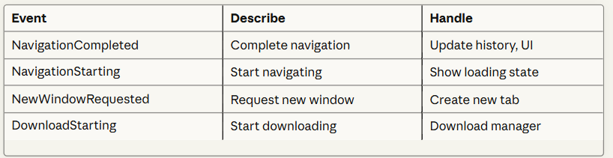Screenshot mô phỏng:
Image 1: WebView2 loading facebook.com page with progress bar 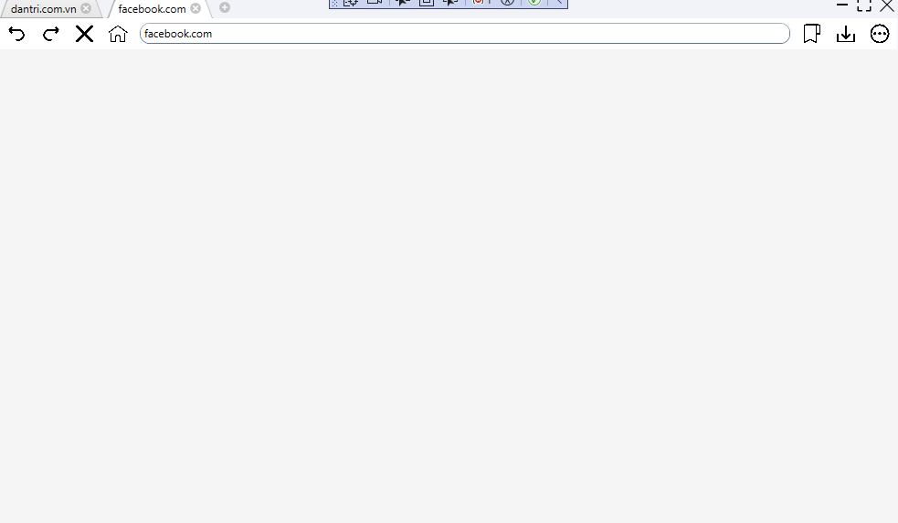
Image 2: The website has loaded, displaying full content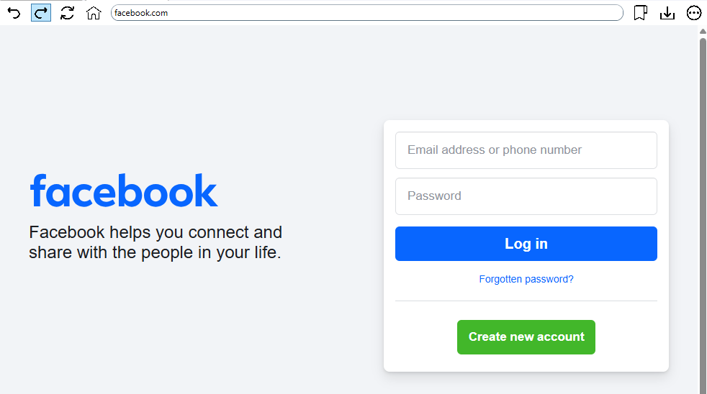

2.3 Modal Windows và Popups
2.3.1 AI Summary Window
Trigger: Click button" Summarize" ontoolbar
Component | Description / Displayed Content
Window Title | AI Summary – Displays the window title with a [Close] button to exit.
AI Icon | Animated Character – Shows an animated AI character or icon indicating processing activity.
Page Summary Content | - Key Point 1: Main topic is ...- Key Point 2: Article discusses ...- Key Point 3: Conclusion shows ...
Additional Information | Generated by Gemini AIProcessing time: 3.2s
Action Buttons | [ Copy Summary] – Copy the summarized text.[Close] – Close the summary window.

Simulation screenshot:
Image 1: Choose AI summary
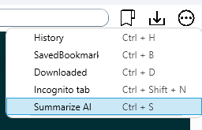
Hình ảnh 2: Summary result với formatted bullet points]
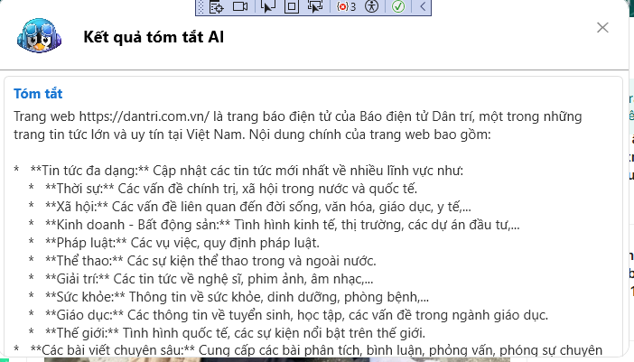
2.3.2 Bookmark Manager
Trigger: Menu → Bookmarks
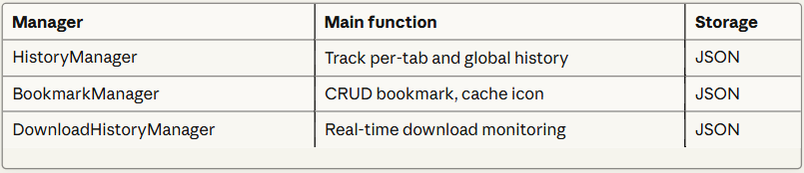
Simulation screenshot:
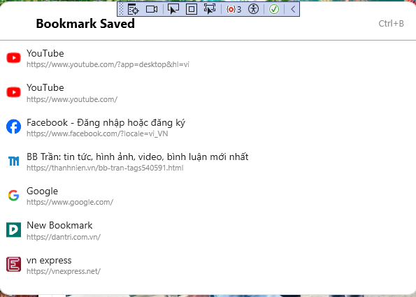
2.3.3 History Viewer
Trigger: Menu → History
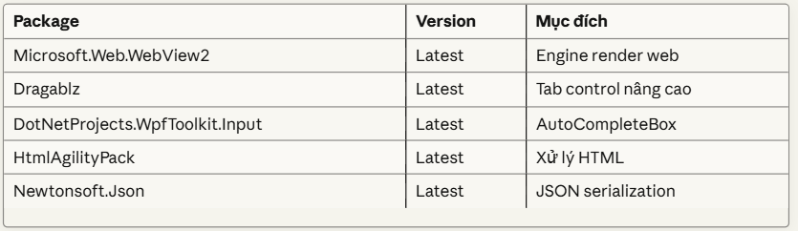Screenshot :
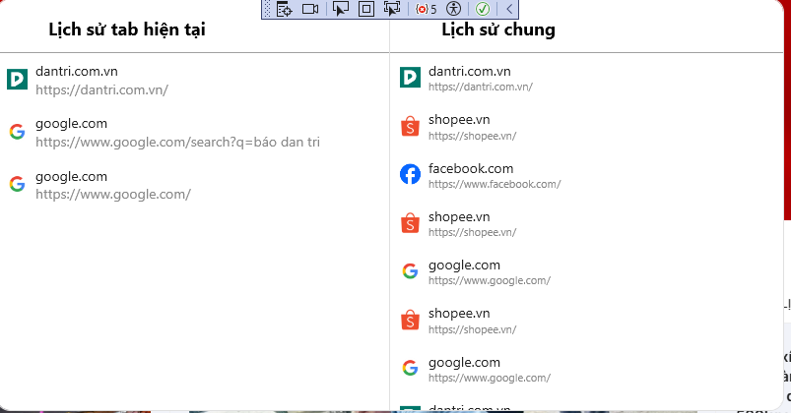
2.3.4 Downloads Manager
Trigger: Click button Downloads
Type: Flyout panel from right side
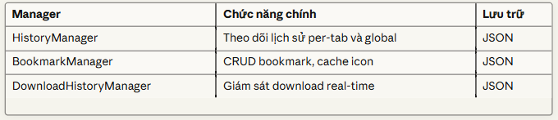
Features:
- Active Downloads: Progress bar, pause/cancel
- Completed: List với timestamps
- Quick Actions: Open file, Show in folder
- File Info: Size, download date, location
- Clear History: Remove completed downloads từ list
Screenshot :
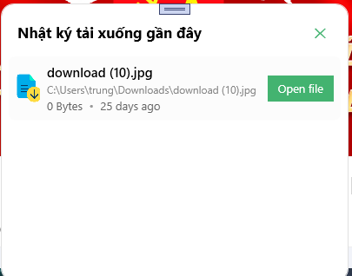
2.4 Incognito Mode Visual Differences
Tab Appearance:
Mode | Example Appearance | Theme Color | Data Stored
Normal Tab | “MyWebBrowser – Home” | Light / Default | History, cookies, bookmarks
Private Tab | “Private Tab 1” | Dark / Purple | None (temporary session)

Window Indicator:
- Title bar: "MyWebBrowserVer4 (Incognito)"
- Tab color: Dark purple (#6B46C1)
- Icon: Shield/lock symbol
- No history/bookmark saving
Visual Cues:
- Purple accent color throughout
- "Private" label on tabs
- No history dropdown suggestions (chỉ static domains)

CHAPTER 3 : CONCLUSION AND PROJECT DEVELOPMENT DIRECTION
3.1 Achievements
- Built a modern web browser using WPF and .NET 8.
- Core features: flexible tab browsing (Dragablz), WebView2 rendering, and comprehensive data management (History, Bookmarks, Downloads).
- Applied MVVM architecture and patterns like Factory and Observer for maintainable code.
- Features: fully isolated incognito mode, smart autocomplete from multiple sources, and Google Gemini AI integration for webpage summarization.
3.2 Limitations:
- API key hardcoded → security risk.
- Incomplete exception handling, may cause crashes.
- No user settings system for customization.
- Lack of unit tests and detailed documentation → harder to maintain and scale.
3.3 Next Development Roadmap:
- Platform improvement (3–6 months): Secure API keys, full error handling & logging, user settings, unit & integration tests.
- Feature expansion (6–12 months): Plugin architecture, cross-device sync, multiple AI providers, custom themes, localization.
- Optimization & growth (12+ months): Telemetry system, extension marketplace, memory/startup optimization, advanced security (phishing protection, sandbox mode).
Conclusion:
MyWebBrowserVer4 has a strong foundation with clean architecture and innovative features. Focusing on security, UX, extensibility, testing, and documentation will enable it to become a competitive web browser in the market.
Link Project
https://drive.google.com/drive/folders/11dxHt2xY6B9PKlNGmR_cJRrUqmCNBb0P
Link tham khảo: https://www.flaticon.com/free-icons/back-button

